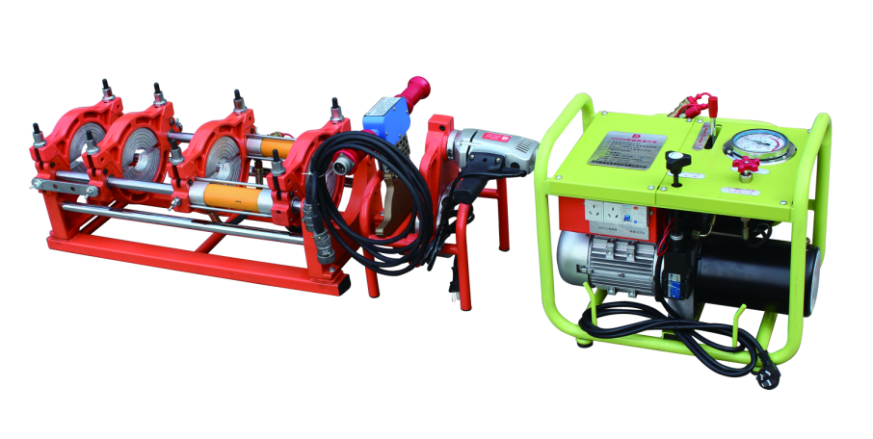
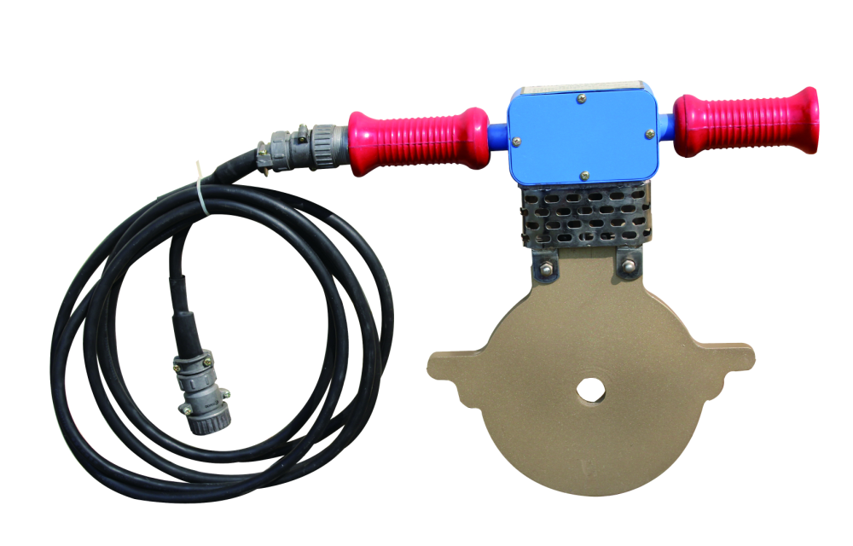
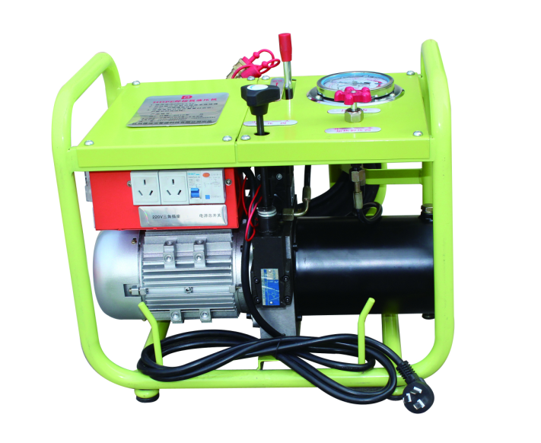
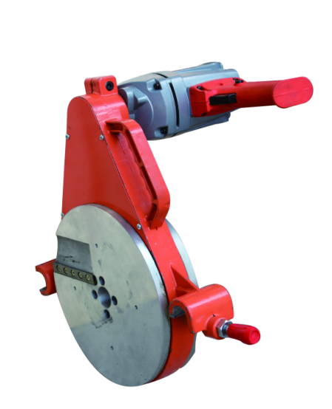
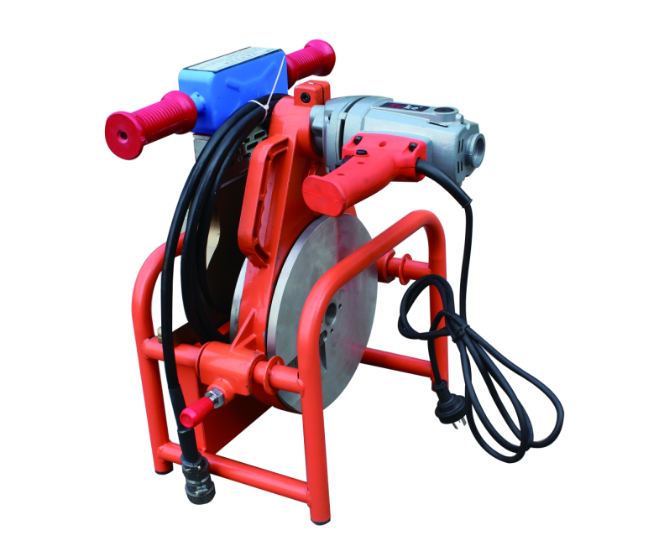

Machine adopts aviation aluminum alloy die casting material made.
Hydraulic power drive.
Aviation cable connector .
quality teflon coated heat plate.
application for PE/PP/PVC/PPR/PVDF etc.
machine details:
fusion range:160,180,200,225,250,280,315mm
butting deviation:under 0.3mm
temperature deviation: under 3degree.
total section of cylinders 22.02cm*cm
heating plate max temperature 299 degree.
operation pressure range :0---45Mpa
required time for welding temperature within 20min.
power: heating plate 2.8kw/220v, planing tool:1.1kw/220v,hydraulic unit:0.75kw/220v

package : basic frame: wooden case:1010*665*550
hydraulic unit:wooden case:730*645*680

total weight: 189kgs

with CFR cost, LCL to Singapore port.： 1695usd in total.

